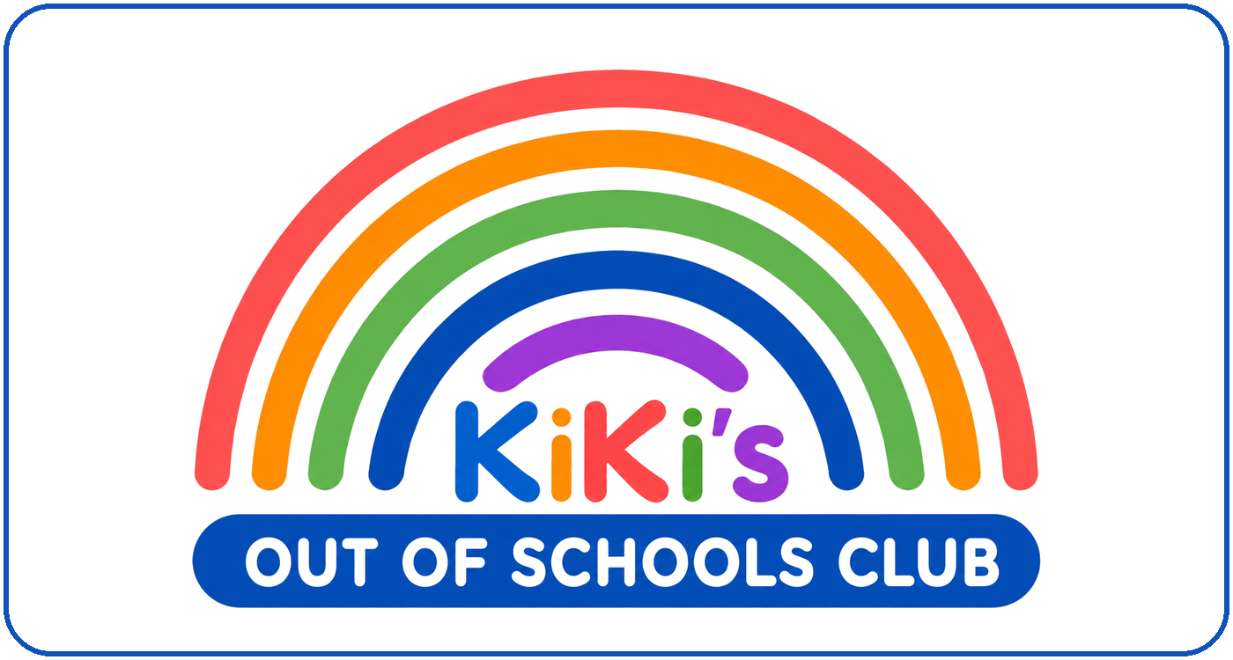 |  | 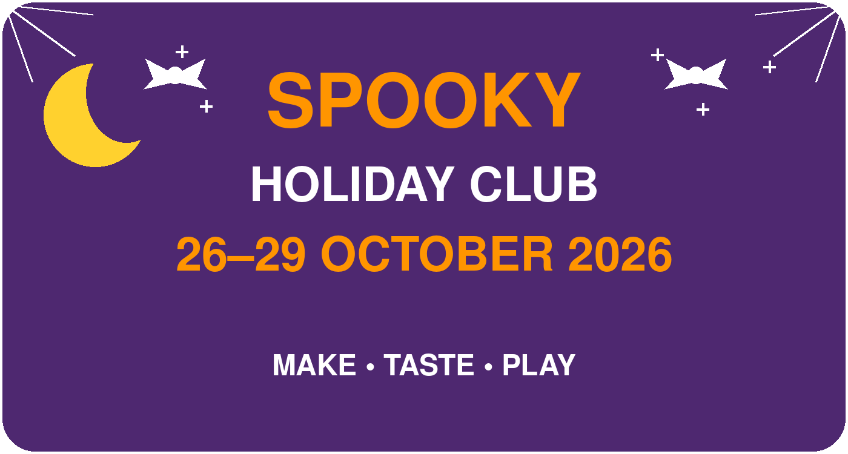
MONDAY 26TH – THURSDAY 29TH OCTOBER 2026
FOUR DAYS OF SPOOKY FUN!
MONDAY  PUMPKIN PARTY    MAKE Pumpkin Plate Painting  TASTE Creepy Cupcakes  PLAY Feed the Monster  Monster Freeze | TUESDAY  GHOSTLY FUN    MAKE Spooky Mobiles*  TASTE Monster Biscuits  PLAY Eyeball Spoon Race  Wrap the Mummy
WEDNESDAY  NEON MONSTERS    MAKE Neon T-Shirt Painting**  TASTE Spooky Treats  PLAY Spooky Relay Race  Monster Corners | THURSDAY  MONSTER MASH    MAKE Build a Monster  TASTE Magic Mocktails  PLAY Monster Freeze  Spooky Walk to Hunts Grove Park
*TUESDAY: BRING A COAT HANGER • **WEDNESDAY: BRING A T-SHIRT

