Gunpowder Plot
Guy Fawkes and other tried to blow up Parliament on 5th November 1605.
We now celebrate bonfire night across Great Britain and set off fireworks and start bonfires.
Great Fire of London
Great Fire of London started on 2nd September 1666.
The fire started in pudding lane in bakers’ shop.
The baker was called Thomas Farynor and Samuel Pepys kept a diary of what happened that night

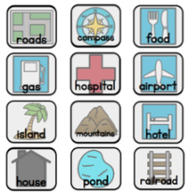
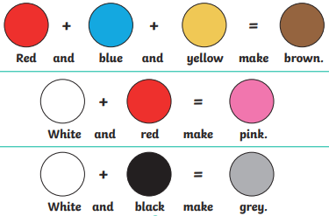
Fire, Fire
A map key
Symbols that are on the map that explain what each one is.

Key vocabulary
Wood - a strong material.
Metal - a shiny, strong material.
Plastic - a transparent, waterproof and strong material.
Glass - transparent and strong if thick and weak if thin material.
Fabric – a flexible, absorbent material.
Rock - a hard and strong material.
Parliament – a group of people who create laws and rules
Colour mixing
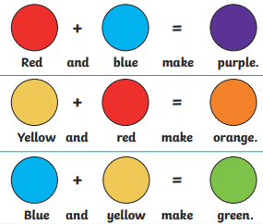

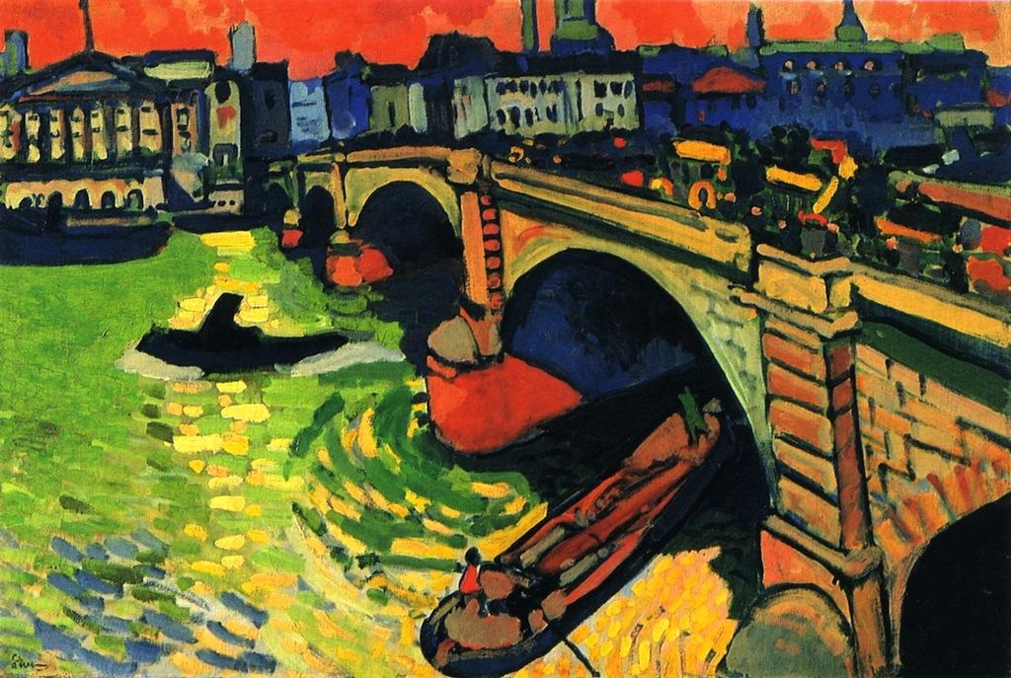
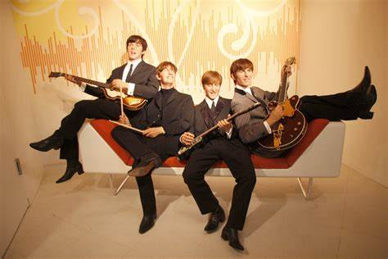
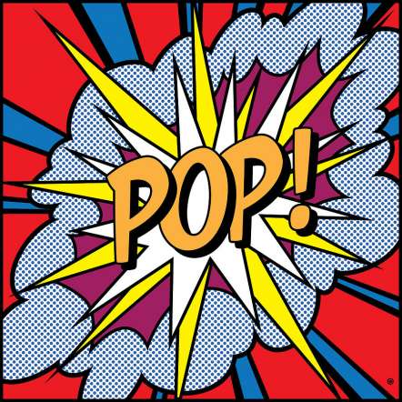
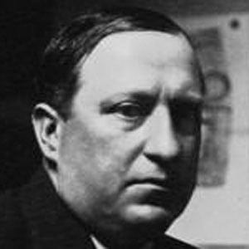
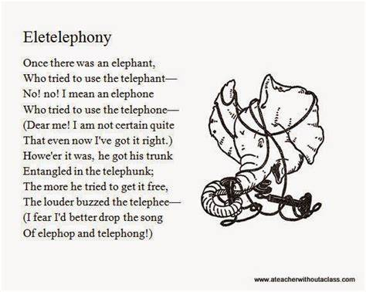
London Bridge 1906
Autumn Music
The Beatles 1960
Pop!

Autumn Poem
Eletelephony by Laura Richards
Autumn Artist
Andre Derain 1880 - 1954

