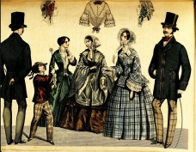
The UK
Key Vocabulary
Reign | The time during which a King or Queen rule.
Act | A law passed by parliament.
Suffragettes | Women who protested for the right to vote.
Suffragists | Men and women who supported women’s right to vote.
Election | When people vote for a person to represent them.
Child labour | Children forced to work like adults.

The Victorians
England is split into 48 counties.
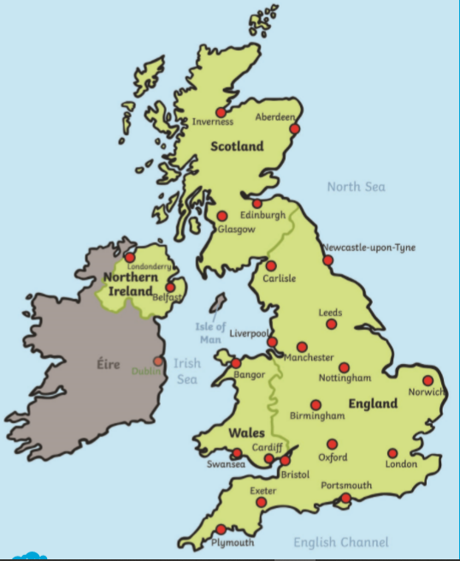

Queen Victoria - Victoria became Queen at the age of 18 and reigned for 64 years from 1837-1901.
Emmeline Pankhurst – helped women win the right to vote.
Sarah Forbes-Bonetta – an African princess who was given as a ‘gift’ to Queen Victoria.

Key Dates

The Victorian era was the period of Queen Victoria’s reign 1837 – 1901
1837 – Victoria becomes Queen
1842 – Mines Act ends child labour
1870 – Education Act. School for everyone
1901 – Queen Victoria dies aged 81. Edward VII becomes King
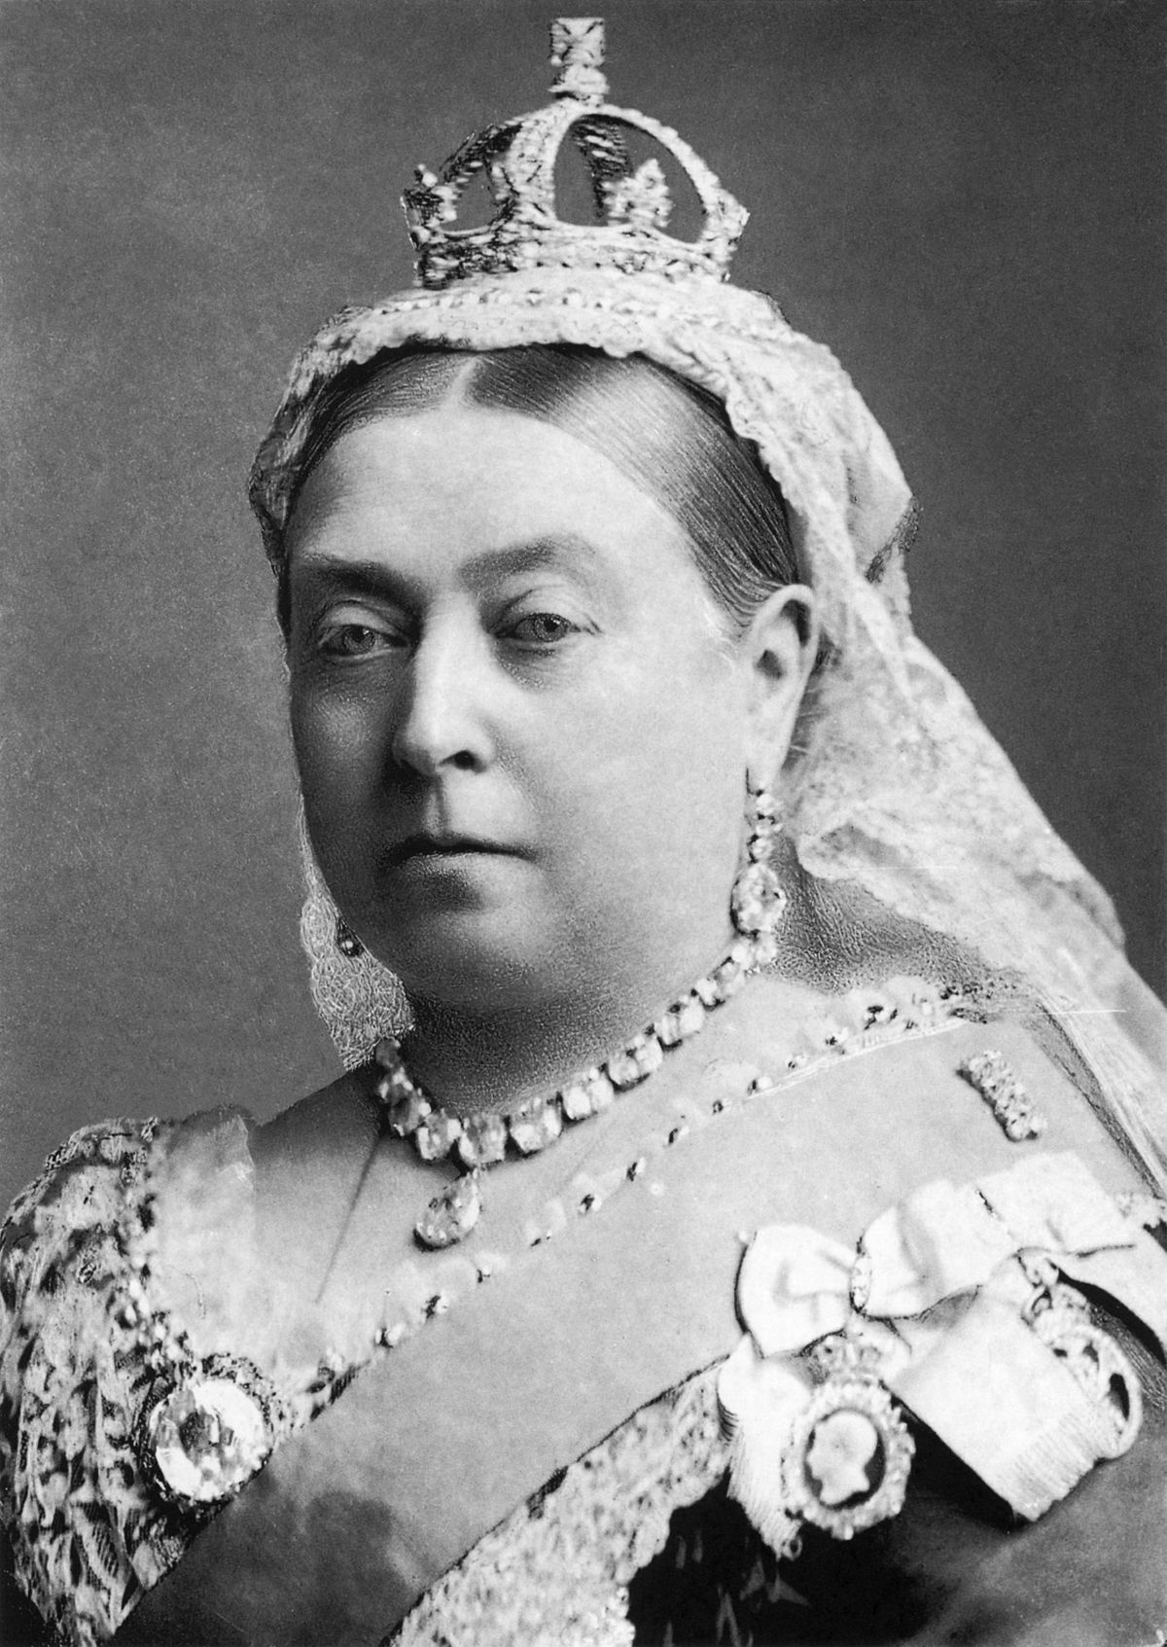

Melia

#

Key Facts
Religion | School | Life | Work
Religion was very important to the Victorians. Many people went to church every Sunday. | Schools were not free until 1891. Teachers were very strict and there could be between 70-80 pupils in the same class. | Rich Victorians enjoyed a good and easy life whereas the poor had a hard, rough life. | Most people, including children worked in factories or mines for 12 hours a day.

Electrical circuit

