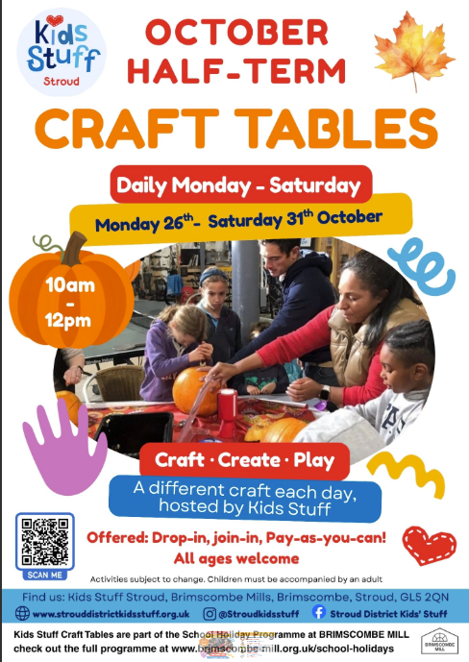
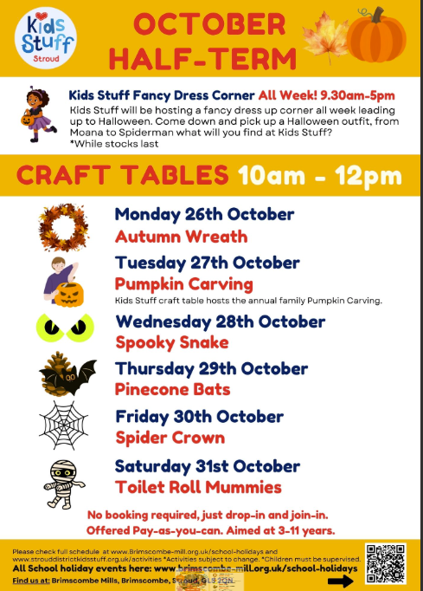
We’re excited to share our October Half Term programme at Kids Stuff Stroud and Brimscombe Mill!

This half term we have lots of fun and creative, Pay-as-you-can and low-cost activities for families to enjoy — from autumn crafts to Halloween activities.
Everyone’s welcome, and we’d love for families from your school community to join in!

From Saturday 24th October – Saturday 31st October, there's so much for families on offer:

Themed Kids Stuff drop-in craft tables 10am - 12pm including family Pumpkin carving, Autumn wreaths and Halloween inspired crafts.
All offered Pay-as-you-can. No booking needed, just drop in and join the fun!

Teen Stuff Sale - Saturday 24th 10am-3pm

Hands on Reptile Experience - Wednesday 28th 10am-12pm (Bookable via Brimscombe Mill website)

The Long Table Kids Kitchen - Tuesday 27th & Thursday 29th 10:30am -12pm

Crafternoon- Learn to Crochet Thursday 29th 1pm - 3:30pm (Bookable via Brimscombe Mill website)

Fancy Dress Family Disco - Thursday 29th 5-7pm

Let's Create - Create, Make, Play in The Sanctuary Friday 30th 10am-12pm

Scavenger Hunt - all week, find the clues claim a free prize.

Pay-as-you-can Kids Lunches from The Long Table (lunchtimes daily, 12–2pm).

You can view the full October Half Term schedule here:

Kids Stuff Stroud www.strouddistrictkidsstuff.org.uk/activities

Brimscombe Mill www.brimscombe-mill.org.uk/schoolholidays

