TBAT – create mathematical statements for multiplication
(multiplied by)
Do it
How many across the top of array
How many down of the array
Write statement
Total number in array


Write statement to match the array.
1. 2.
____ multiplied by _____ = ______ _____ multiplied by _____ = ______
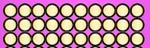

3. 4.
____ multiplied by _____ = ______ _____ multiplied by _____ = ______
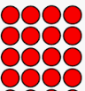
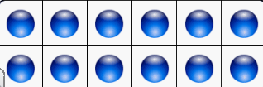
5.
____ multiplied by _____ = ______ _____ multiplied by _____ = ______

