TBAT: tell the time to the hour
Do it
Big hand - minutes
Little hand – hour
Big hand on 12 = o’clock
Little hand on number = that hour
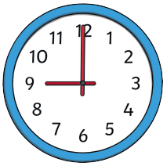
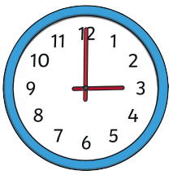
Write the time of the clocks below

_____________________________ _______________________________

 

 

