TBAT: draw hands on a clock face or write out time
using number
Do it
Big hand – minutes
Small hand – hours
Big hand on 12 – o’clock big hand on 6 – half past
Small hand – draw hand to the hour
Big hand – minutes
Little hand – hours
Big hand at 6 – half past
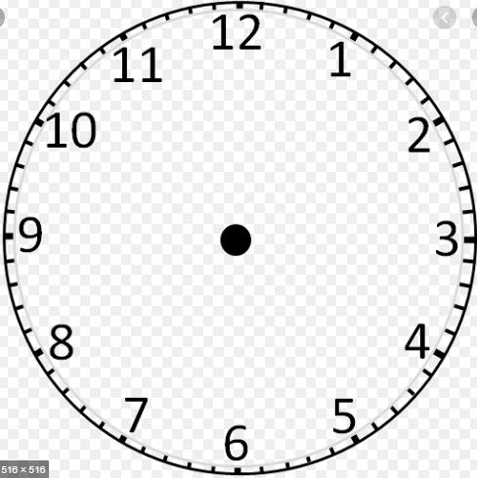
Draw on hands to match the time below the clock.
half past 8 3 o’clock half past 12
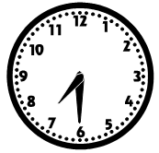
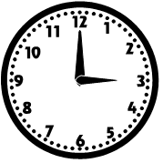
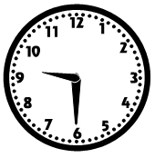

_______________ ______________ __________________
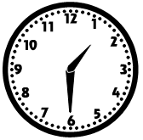

11 o’clock _______________

