TBAT – use mathematical language to describe movement along a straight line
Do it
Which was is object facing?
How it moved along the line or across
Forwards, backwards, left or right
Look at where the animal has moved to and write how they have moved. The way the arrow is facing is the direction the animal is facing.
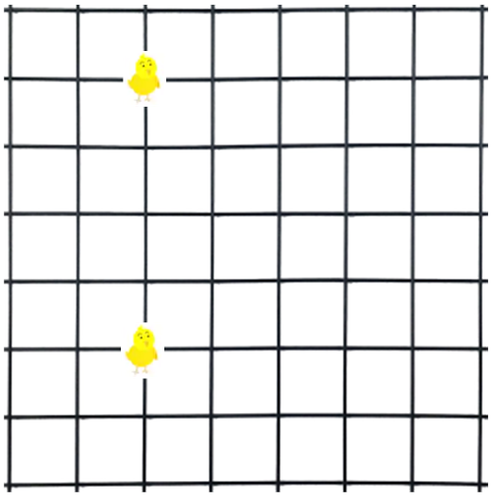
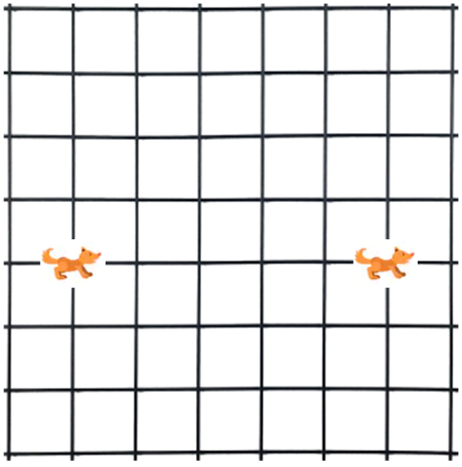
- 2.
________________________________________________ ______________________________________________
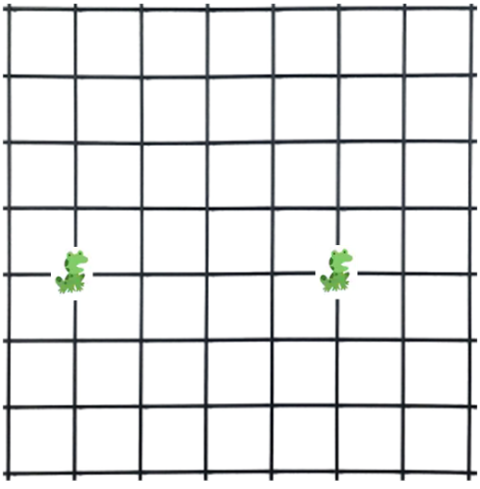
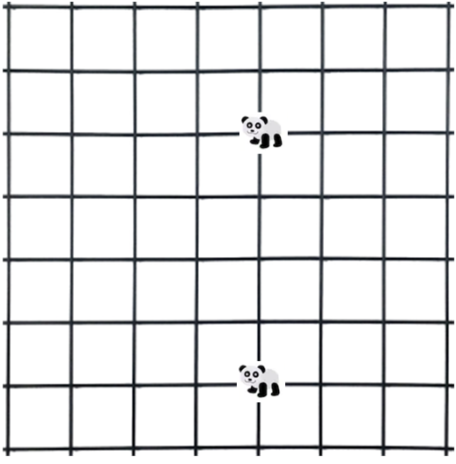
- 4.

________________________________ ______________________________




