TBAT: compare and order temperatures
Use <,> and = to compare the temperatures and then put them in order from coolest to hottest.
F
E
D
C
B
A
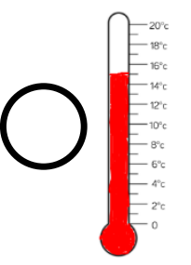
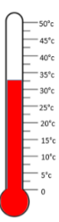
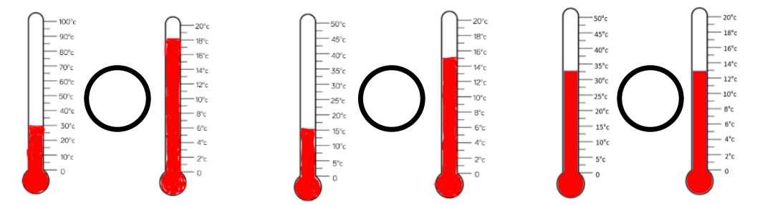
Coolest to hottest order
________________________________________________________________________________
Mollie took the temperature at 12pm and again at 5pm.
H
G
Mollie took the temperature at 12pm and again at 5pm.
There was a difference of 7ºC.
What could the temperature be?



