TBAT: interpret a pictogram where the symbol equals 1
Total for each fruit equals 1 child
Count total fruit
Each fruit is equal to 1 child.
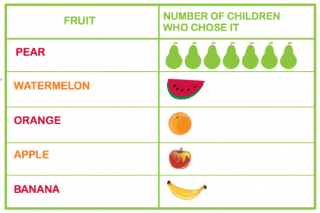
- How many children chose orange? _________________
- How many children chose pear? _______________________
- How many children chose apple and watermelon? __________________
- How many children chose orange and apple? _________________
- How many more children chose pear than banana? ________________
- How many more children chose pear than apple and orange? _________
- What is the total of all the fruit chosen? __________________
- What is the different between children choosing pear and orange? ________

