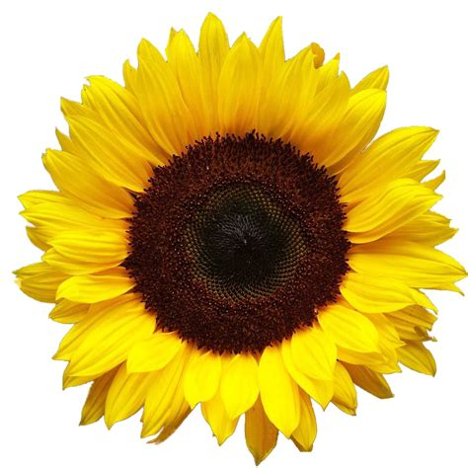
English
We will be writing:
- Non-fiction texts
- Animal stories
- Instructions
- Animal poems
- Letters
Maths
We will be working on:
- Fractions
- Multiplication and division
- Problem solving
- Times tables
- Measure
- Time

Art
We will be starting with some silhouette art based around Nick Sharratt’s book The Foggy, Foggy Forest. Then we will be doing a study of Chris Ofili and his work using elephant dung!
RE
In RE, we will be looking at the Trinity and why it is important to Christians. We will also be looking at the kind of world Jesus wanted us to live in.
Science
In Science, we will be looking at plants and animals. We will explore the different parts of flowering plants and look at the life cycle of a seed. We will be looking at the various ways animals can be grouped and classified. We will then look at different life cycles, food chains and ways animals have adapted to their environment. We will also look at how changes to the environment can pose dangers to living things.
Computing
Our computing unit this term will be looking at different uses of the internet including how it can be used for communication.

PE
This term we will be swimming every Tuesday afternoon at Stratford Park Leisure Centre.
Music
We will continue to learn to play the recorder. We will be learning to read and play some more notes and using these to play more complex tunes.
PSHE
This term we will be focusing on kindness – being kind to each other, being kind to our environment and everything living in it!
Roots, Shoots and Poops!



