The big under world discovery

I am a scientist and today I was excited to explore the Titanic wreck, I hoped to find, through the camera, buried treasure as well as different creatures in the midnight zone. I was using a robot camera because the Titanic is 1,000 meters deep.

I lifted my shining blue robot into the water and then I let it go, it swayed in the water and then disappeared under the surface. I could see through the robot’s camera hundreds of different species of fish swimming in all directions 10 seconds later I saw dark murky water and long slimy seaweed floating underneath the water. When I looked through the camera again it was pitch black. I knew we had arrived at the midnight zone.

I could see star fish, some were short and thin and some big and blue, they were moving very slowly and patiently, some were prickly and some were smooth and some had 40 beautiful arms! I also saw Jelly Fish that were blue, orange and sometimes pink, they looked as soft as a pillow, but I knew they were as deadly as a Nile crocodile! They were using their long thin tentacles to catch prey that was in their path. As a scientist Jelly Fish interest me because they have been around for 650 million years.

A few seconds later I saw eels that were as long as a bus they were hiding under a rock ready to speed out and catch their prey.

Then I saw it, the looming shape of the Titanic, I felt amazed that we had reached it, there were treasures all over it. I could imagine being on the largest cruse liner in the world I would have been partying! I saw huge clams that were as huge as a cricket ball on the stern and bright pink and sky-blue sea urchins as spiky as a porcupine on the bow. There were also crabs that were as tiny as a mouse and some as big as a child’s hand. They were scuttling around playing. I couldn’t have imagined 108 years later the Titanic would have made a beautiful coral reef home to many different animals and sea creatures.

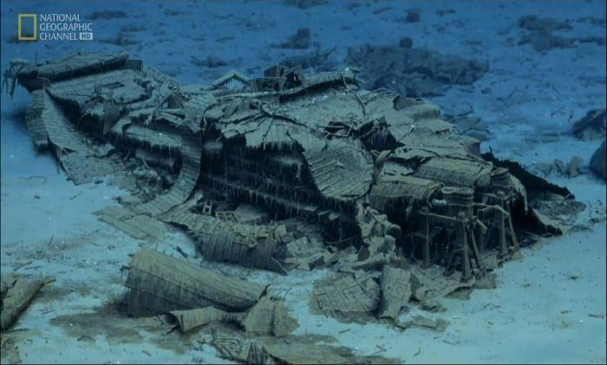
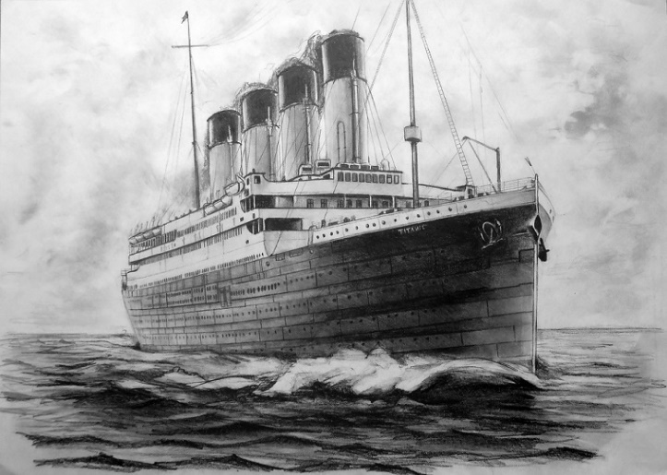

By Ewan Williams

