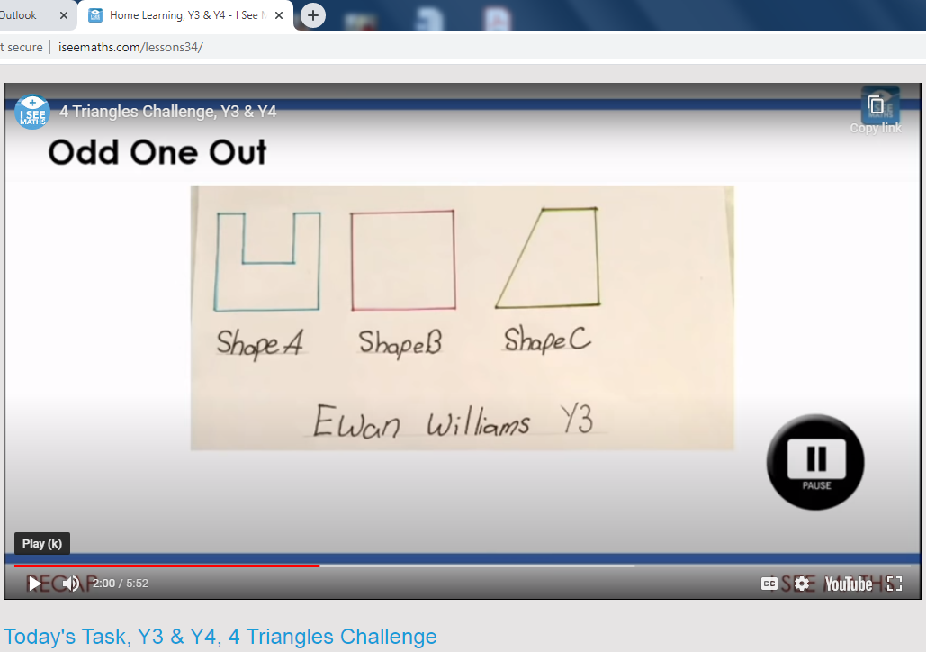
Ewan has written a challenge for ISee Maths which was published today. If you want to see the whole programme, follow the link below.
http://www.iseemaths.com/lessons34/
Well done Ewan!

